Guideline for changing the background image in Zoom

- Select «settings», right side button (marked in red)
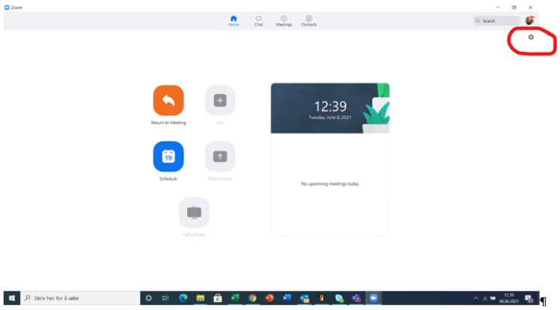

- Choose «Background & Filters»
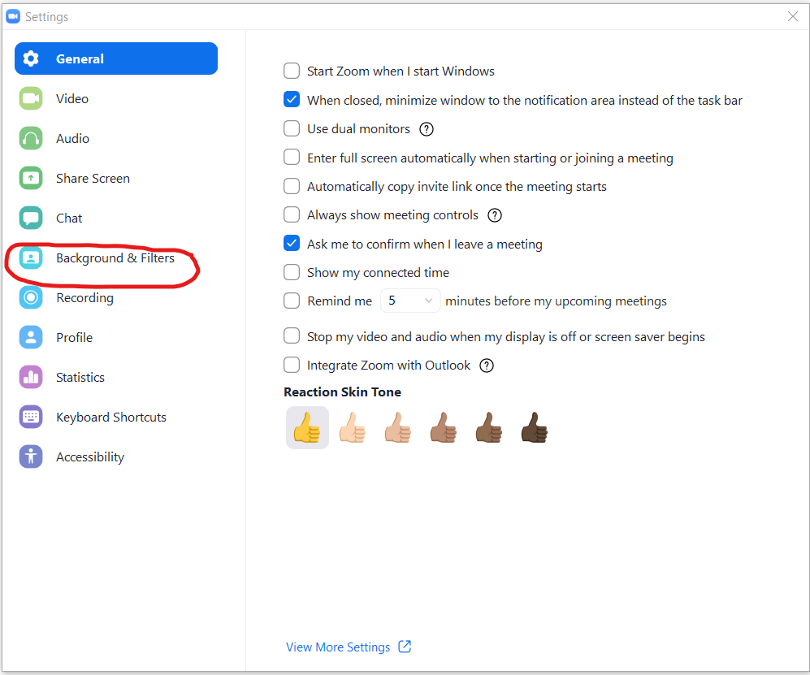

- Select the pluss button «Add image or video”
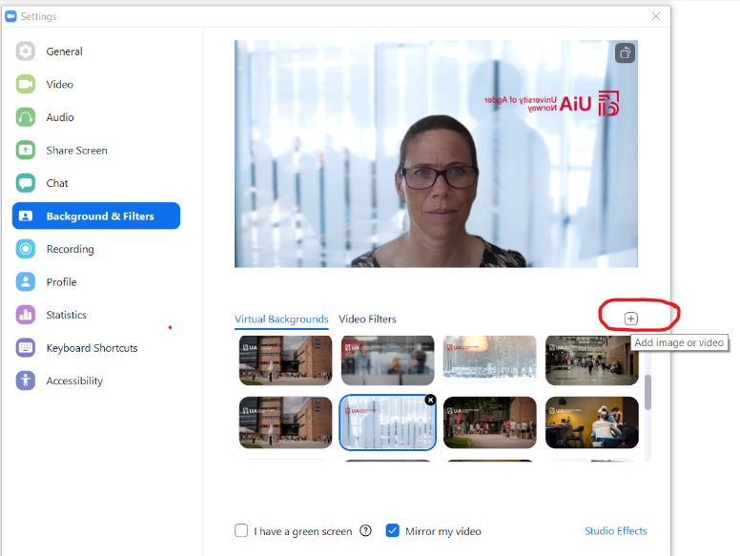

- Find the image you want in your folder and select this one.
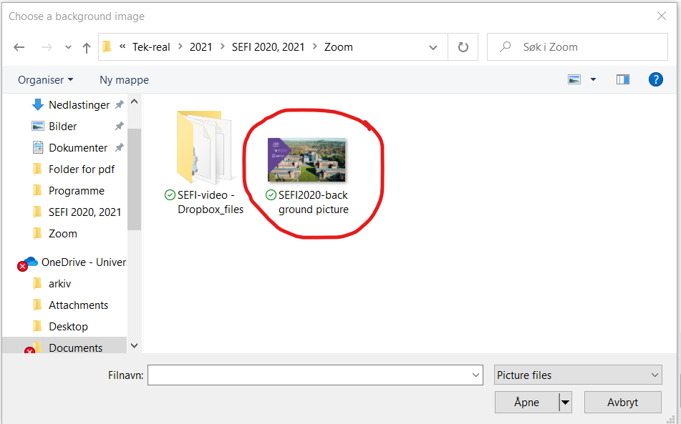

- The image will put itself as the last image in the list of virtual backgrounds.
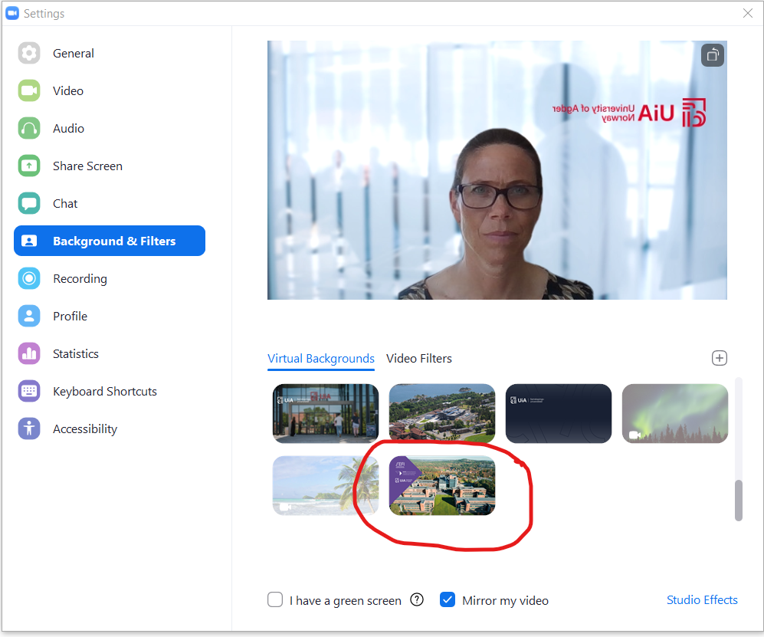

- Select the image and check that the background is the one you want. Then close. The image will be visible when joining Zoom.
